**VISVESVARAYA TECHNOLOGICAL UNIVERSITY, BELGAUM**

“Jnana Sangama”, Belgaum-590018

****

**A Report On**

**“EasyGo Car Rental”**

Submitted by

**TANMOY MAZUMDAR 4NI19IS104**

**SOURABH KUMAR 4NI19IS099**

Under the Guidance of

**Ms. Prathibha.B.S., Ms.Shwetha GN., Ms. Monika Nag KJ.,**

Assistant Professor Assistant Professor Assistant Professor

**Dept of IS&E Dept of IS&E Dept of IS&E**

**NIE, Mysuru NIE, Mysuru NIE, Mysuru**

****

**The National Institute of Engineering Department of Information and Engineering**

**MYSURU-570008 MYSURU-570008**

**2021-2022**

**THE NATIONAL INSTITUTE OF ENGINEERING**

**MYSURU-570008**

**Department of Information Science and Engineering**

|  |  |
| --- | --- |
|  | **D:\Documents and Settings\Chandan\Desktop\WhatsApp_files\pp_013.jpg** |

**CERTIFICATE**

Certifies that the project work titled “**EasyGo Car Reantal System**” is a work carried out by **TANMOY MAZUMDAR(4NI19IS14), SOURABH KUMAR(4NI19IS099)** in partial fulfilment for the requirements of the fourth semester BE in Information Science & Engineering prescribed by The National Institute of Engineering, Autonomous Institution under Visvesvaraya Technological University, Belagavi. It is certified that all corrections/suggestions indicated for Internal Assessment have been incorporated. The Project report has been approved as it satisfies the academic requirements in respect of the project work prescribed for the fourth semester in Data Base Laboratory.

Signature of Guides Signature of HOD Signature of Principal

(Dr. P Devaki ) (Dr NV Raghavendra)

Name of the Examiner Signature with Date



**ABSTRACT**

A car rental is a vehicle that can be used temporarily for a period of time with a fee.

Renting a car assists people to get around even when they do not have access to their own

personal vehicle or don't own a vehicle at all. The individual who want to rent a car must

first contact the car rental company for the desire vehicle. This can be done online. At

this point, this person has to supply some information such as; dates of rental, and type of

car. After these details are worked out, the individual renting the car must present a valid

Identification Card.

Most companies throughout the industry make a profit based of the type of cars that are

rented. The rental cars are categorized into economy, compact, compact premium,premium and luxury. And customers are free to choose any car of their choice based ontheir purse and availability of such car at the time of reservation.

**ACKNOWLEDGEMENT**

The success and the final outcome of this project required a lot of guidance and assistance from many people and we are extremely fortunate to have got this all along the completion of project work.

We express our profound thanks to **Dr. NV Raghavendra*,*** Principal, NIE, Mysuru for her much-needed moral support and encouragement.

We are grateful to **Dr. P DEVAKI*,*** Prof.& H.O.D., Information Science and Engineering, NIE for her support and encouragement in facilitating the progress of this work.

We sincerely extend our thanks to our project Guides **Ms. Swetha GN and**

**Ms. Monika Nag KJ** Assistant Professor in the Dept. of I.S.&E., for their guidance, technical expertise, encouragement and timely help in making this project a reality.

Also, we would like to extend our sincere regards to all the non-teaching staff of the IS&E Dept. for their timely support.

**TANMOY MAZUMDAR 4NI19IS104**

**SOURABH KUMAR 4NI19IS099**

**TABLE OF CONTENTS**

**Sl. No. Chapter Page No.**

1.Introduction 1

2. Proposed System 2-4

3. System Design 5-10

4. Implementation 11-16

5. Conclusion & Future Enhncement17

6. ScreenShots18-30

# 

# CHAPTER I: INTRODUCTION

Nowadays, there is Online Car Rental which gives much benefit to user. A rental service is a service which customers arrive to request the hire of a rental unit. It is more convenient than carrying the cost of owning and maintain the unit. A car rental is a company that rent automobiles for short period of time for a fee for few hours or a few days or a week.

It helps to book the cars or vehicles online rather than using the traditional manual system of vehicle reservation. This eliminates the risk of erroneous booking and reduce overall lead time and ensures growth in customer satisfaction. They can book any car according to their brands and price.

Our Project EasyGo Car rental System provides the users easy and convinient way to rent awvailable cars on the basis of brands and car types with previlege of selection of pickUp and Drop Location and also the date for the pickup and drop.And a auto generated bill is provided to the user on the basis of the service they have chosen.

The objective of the project is to automate vehicle rental ad reservation so that the customers do not need to call and spend unnecessary time to reserve a vehicle.To transform the manual process of hiring car to a computerize system,To validate the Rental car system using user satisfaction test,To produce the documentation such as Software Requirement Specification(SRS), Software Design Description as system development reference.

# CHAPTER II: PROPOSED SYSTEM

## EasyGo Car Rental System project will enable the user to rent a vehicle. The user can check for availability of cars. The user specifies a type of car and the journey date and time. The Car Rental System shall check for the availability of the car and rent the car to the customer. The tool is designed using VB.net. All the data regarding the rental cars are stored in MySQL database . The user has to enter his name, address, phone details and check for the cars available for rent. The UI is eyecatching and user-friendly and the connectivity to back end is robust. The main advantage is that the user shall be able to choose a car depending on his budget.

## 

The objective of the project is to automate vehicle rental ad reservation so that the customers do not need to call and spend unnecessary time to reserve a vehicle.

* To transform the manual process of hiring car to a computerize system
* To validate the Rental car system using user satisfaction test
* To produce the documentation such as Software Requirement Specification(SRS), Software Design Description as system development reference

**TECH STACK USED**

For the development of project the designing of database was done on PHPMYADMIN with MYSQL, back end was coded in basic PHP and for frontend we used HTML,CSS,JAVASCRIPT and same basic PHP codes.

**TOOLS USED**

* **Xampp:**
  + **MySqlServer:** 
    - It handles larege databases much faster than existing solutions.
    - It consists of multi-threaded SQL server that supports different back ends, several different client programs and libraries, administrative tools, and application programming interfaces (APIs)
    - Its connectivity, speed, and security make MySQL Server highly suited for accessing databases on the Internet.
* **Sublime Text 3.1.1-** Sublime Text is a sophisticated text editor for code, markup and prose. In this project we have used this to write the code for PHP scripts and als HTML and CSS codes.
* **MYSQL Workbench-** Mysql Workbench is used in this project to write the mysql code for the database.
* **Web browsers**: Google Chrome,Mozilla Firefox, Opera and Internet Explorer.
* **Git Hub**: GitHub Inc. is a web-based hosting service for version control using Git. It is mostly used for computer code. It offers all of the distributed version control and source code management functionality of Git as well as adding its own features.In this project we have used this to work in a project so that everyone acess and modifies in a singe repo with different branches.

**Functional Requirements**

1. Admin Login: The system should allow the admin to Log In with correct credential online and Access to the data information of the service.
2. Online reservation of cars: Customers should be able to use the system to make

booking and online reservation.

c. Automatic update to database once reservation is made or new user registered:

Whenever there’s new reservation or new registration, the system should be able

update the database without any additional efforts from the admin.

d. Feedbacks to customers: It should provide means for customers to leave feedback.

**Non-Functional Requirements**

It describes aspects of the system that are concerned with how the system provides the

functional requirements. They are:

a. Security: The subsystem provide a high level of security and integrity of the

data held by the system, only authorized personnel of the company can gain access

to the company’s secured page on the system.The password in the system is also

encrypted for make the system data more secured with sha1 when store in database.

b. Performance and Response time: The system have high performance rate

when executing user’s input and is able to provide feedback or response

within a short time span usually 3 seconds for highly complicated task and 1 to

2 seconds for less complicated task.

c. Error handling: Error is considerably minimized and an appropriate error

message that guides the user to recover from an error should be provided.

Validation of user’s input is highly essential. Also the standard time taken to

recover from an error should be 15 to 20 seconds.

d. Availability: This system is always be available for access at 24 hours, 7 days

a week. Also in the occurrence of any major system malfunctioning, the system

should be available in 1 to 2 working days, so that the business process is not

severely affected.

e. Ease of use: Considered the level of knowledge possessed by the users of this

system, a simple but quality user interface is developed to make it easy to

understand and required less training.

# CHAPTER III: SYSTEM DESIGN

Various Design concepts and processes were applied to this project. Following concepts like separation of concerns, the software is divided into individual modules that are functionally independent and incorporates information hiding. The software is divided into 3 modules which are Client, Cars and Users. We shall look at each module in detail.

**USE CASE DIAGRAM**

**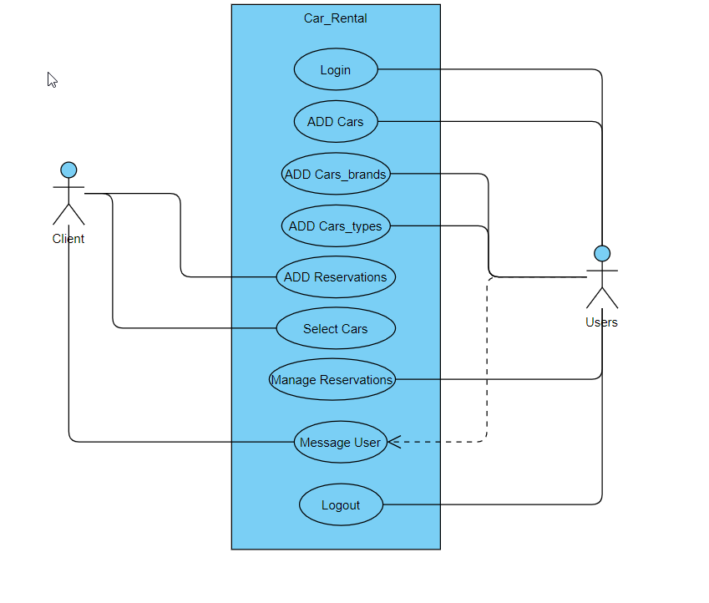**

Figure 1: Use Case Diagram

Above figure represents Use Case Diagram of the project and is a useful technique for identifying, clarifying, and organizing system requirements. It describes how a user uses a system to accomplish a particular goal. A use case diagram can identify the different types of users of a system and the different use cases and will often be accompanied by other types of diagrams as well. The use cases are represented by either circles or ellipses.

**CLASS DIAGRAM**

The class diagram states the different classes involved in the software. For each class, a set of attributes and method are included. The relationship between the classes are also specified.

For example, the Car\_brand class has the attribute brand\_id, brand\_name, brand\_iamge. Each instance of the car\_brand class belongs to a Car. This is specified by the relationship between Car\_brand and Cars.

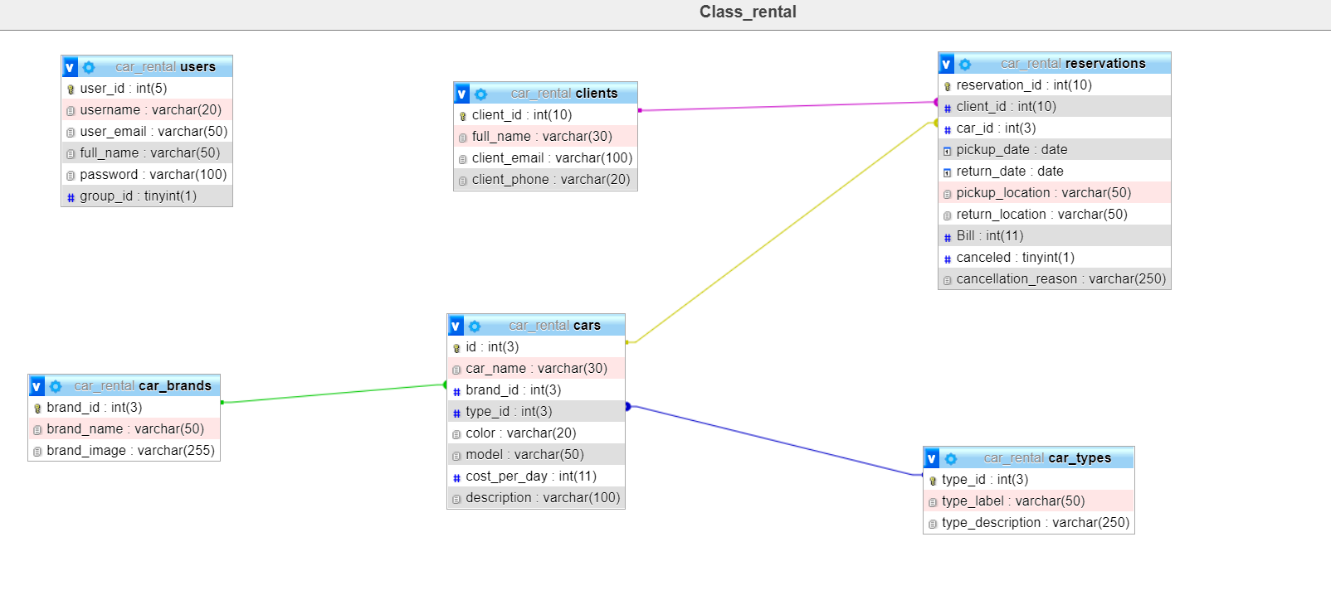

Figure 2: Class diagram of Car rental ERP

**ENTITY RELATIONSHIP DIAGRAM (ER)**

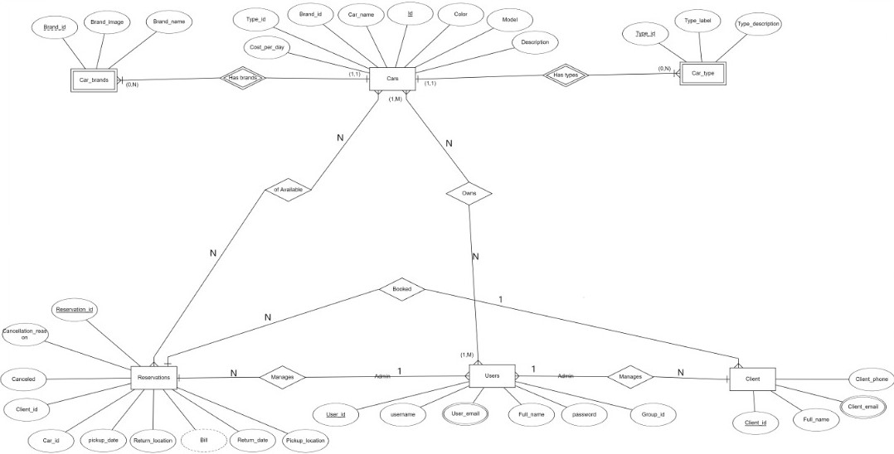An entity relationship diagram (ERD) shows the relationships of entity sets stored in a database. An entity in this context is an object, a component of data. An entity set is a collection of similar entities. These entities can have attributes that define its properties. By defining the entities, their attributes, and showing the relationships between them, an ER diagram illustrates the logical structure of databases. ER diagrams are used to sketch out the design of a database.

Figure 3: Entity Relationship diagram of Car rental

**Entites & their attributes in ER Diagram**

Cars - The cars entity has the folowing attributes named id , Car\_name,Color

Brand\_id, Type\_id, model, description,cost\_per\_day , with id as the key

Attribute.

Car\_Brand- The car\_brand entity has the folowing attributes named brand\_id ,

brand\_name,brand\_image , with brand\_id as the key Attribute.

Car\_Type - The cars entity has the folowing attributesType\_id , Type\_label,

Type\_description, with Type\_id as the key Attribute.

Reservations - The reservations entity has the folowing attributes named

Bill, Reservation\_id, Car\_is,Canceled,Client\_id,Pickup\_date,

Cancellation\_reason, Pickup\_location,Return\_date,

Return\_location with Reservation\_id as the key Attribute

Users(Admin) -The users(admin) entity has the following attributes named

User\_id,Username,User\_email,Full\_name,password,Group\_id

With User\_id as its key attribute.

Clients - The client attribute has the following named Client\_id, Client\_email,

Client\_phone,Full\_name wit Client\_id as its key atrribute.

**Data Flow Diagram**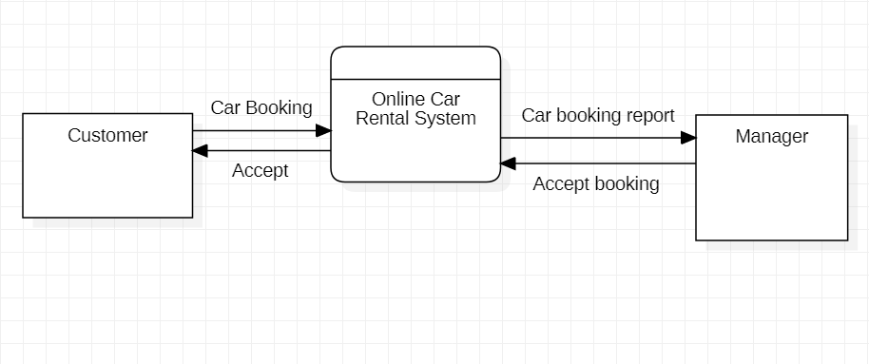

Figure 4: Data Flow Diagram

# CHAPTER IV: IMPLEMENTATION

**Architectural model**

The Car rental software requires the architectural design to represent the design of the software. Here we define a collection of hardware and software components and their interfaces to establish the framework for the development of this software.

There exists number of components of the system which are integrated to form a system. The set of connectors will help in coordination, communication, and cooperation between the components. The Car rental software is built for computer-based system. It exhibits the data centric style of architecture.

The architecture comprises of various modules as given in the figure. There are 2 major categories in which the whole architecture is divided. These are user and client. The architecture is designed such a way that it is self explanatory. The admin/user roles are user management, car management, reservation management.

The role of user includes car data entering, reservation management, client data management. While the roles of client are few in number and includes their complete reservation details like pickup date, location and give feedback.

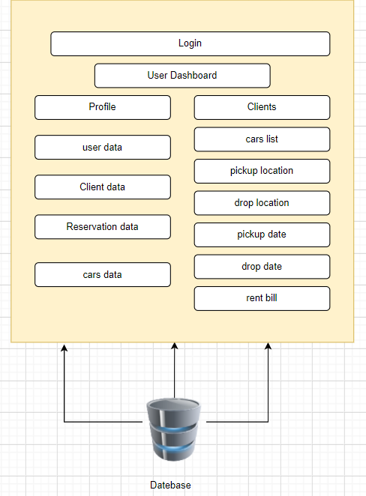

Figure 5: architecture

Any Information System needs to communicate with external entities, human users or other computers. Presentation layer allows these entities to interact with the system; it can also be implemented as a GUI interface and can be referred to as the client of the IS.

Application layer do more than information delivery, they perform data processing (Business Logic and calculation) behind the results being delivered. This tier is often referred as

1.Services

2.Business rules

3.Business logic

4.Servers

The database layer is implemented using a Database Management System which in our case is MySql.

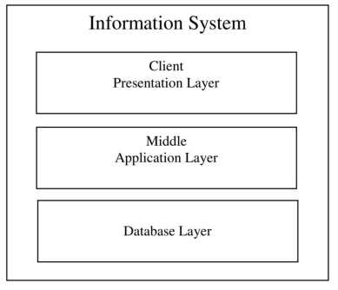

Figure 6: 3 tier architecture

# Sql Database Code

-- Table structure for table `car\_brands`

--

CREATE TABLE `car\_brands` (

`brand\_id` int(3) NOT NULL,

`brand\_name` varchar(50) NOT NULL,

`brand\_image` varchar(255) NOT NULL

) ENGINE=InnoDB DEFAULT CHARSET=utf8;

--

-- Dumping data for table `car\_brands`

--

INSERT INTO `car\_brands` (`brand\_id`, `brand\_name`, `brand\_image`) VALUES

(1, 'Audi', 'Audi-A4-Avant-1.jpg'),

(2, 'BMW', 'bmw-3-series-sedan.jpg'),

(3, 'Lexus', '2016-Lexus-RX-350-BM-01.jpg'),

(4, 'Mercedes Benz', 'Mercedes-C-Class-Estate-1.jpg'),

(5, 'MINI', '2016-MINI-Cooper-S-Clubman-ALL4.jpg'),

(6, 'Porsche', 'P14\_0596\_a4\_rgb-1.jpg');

-- --------------------------------------------------------

--

-- Table structure for table `car\_types`

--

CREATE TABLE `car\_types` (

`type\_id` int(3) NOT NULL,

`type\_label` varchar(50) NOT NULL,

`type\_description` varchar(250) NOT NULL

) ENGINE=InnoDB DEFAULT CHARSET=utf8;

--

-- Dumping data for table `car\_types`

--

INSERT INTO `car\_types` (`type\_id`, `type\_label`, `type\_description`) VALUES

(1, 'Sedan', 'A sedan has four doors and a traditional trunk.'),

(4, 'Coupe', 'A coupe has historically been considered a two-door car with a trunk and a solid roof.'),

(6, 'HATCHBACK', 'Traditionally, the term \"hatchback\" has meant a compact or subcompact sedan with a squared-off roof and a rear flip-up hatch door that provides access to the vehicle\'s cargo area instead of a conventional trunk.');

-- --------------------------------------------------------

--

-- Table structure for table `clients`

--

CREATE TABLE `clients` (

`client\_id` int(10) NOT NULL,

`full\_name` varchar(30) NOT NULL,

`client\_email` varchar(100) NOT NULL,

`client\_phone` varchar(20) NOT NULL

) ENGINE=InnoDB DEFAULT CHARSET=utf8;

--

-- Dumping data for table `clients`

--

INSERT INTO `clients` (`client\_id`, `full\_name`, `client\_email`, `client\_phone`) VALUES

(1, 'Jhon Doe', 'gayatri@good.com', '987654321'),

(2, 'sourabh', 'fuckyou@gmail.com', '918273645'),

(3, 'shubham', 'subham@bad.com', '987654321'),

(7, 'sourabh', 'sourabh@good.com', '987654321'),

(8, 'tanmoy', 'tanmoy@go.com', '918273640');

-- --------------------------------------------------------

--

-- Table structure for table `reservations`

--

CREATE TABLE `reservations` (

`reservation\_id` int(10) NOT NULL,

`client\_id` int(10) NOT NULL,

`car\_id` int(3) NOT NULL,

`pickup\_date` date NOT NULL,

`return\_date` date NOT NULL,

`pickup\_location` varchar(50) NOT NULL,

`return\_location` varchar(50) NOT NULL,

`Bill` int(11) DEFAULT NULL,

`canceled` tinyint(1) NOT NULL DEFAULT 0,

`cancellation\_reason` varchar(250) DEFAULT NULL

) ENGINE=InnoDB DEFAULT CHARSET=utf8;

--

-- Dumping data for table `reservations`

--

INSERT INTO `reservations` (`reservation\_id`, `client\_id`, `car\_id`, `pickup\_date`, `return\_date`, `pickup\_location`, `return\_location`, `Bill`, `canceled`, `cancellation\_reason`) VALUES

(1, 1, 1, '2021-06-30', '2021-07-06', 'Agadir', 'manali', 42000, 1, ''),

(2, 2, 2, '2021-07-05', '2021-07-10', 'dhanbad', 'manali', 25000, 1, ''),

(3, 3, 3, '2021-06-30', '2021-07-06', 'ranchi', 'manali', 60000, 1, ''),

(7, 7, 2, '2021-08-18', '2021-07-30', 'banglore', 'mysore', -95000, 0, NULL),

(8, 8, 3, '2021-07-01', '2021-07-07', 'dhanbad', 'dumka', 60000, 0, NULL);

-- --------------------------------------------------------

--

-- Table structure for table `users`

--

CREATE TABLE `users` (

`user\_id` int(5) NOT NULL,

`username` varchar(20) NOT NULL,

`user\_email` varchar(50) NOT NULL,

`full\_name` varchar(50) NOT NULL,

`password` varchar(100) NOT NULL,

`group\_id` tinyint(1) NOT NULL DEFAULT 1

) ENGINE=InnoDB DEFAULT CHARSET=utf8;

--

-- Dumping data for table `users`

--

INSERT INTO `users` (`user\_id`, `username`, `user\_email`, `full\_name`, `password`, `group\_id`) VALUES

(1, 'tommy', 'test\_test@gmail.com', 'Idriss Jairi', 'f7c3bc1d808e04732adf679965ccc34ca7ae3441', 0),

(2, 'sourabh', 'skumardas267@gmail.com', 'sourabh kumar', 'bfe54caa6d483cc3887dce9d1b8eb91408f1ea7a', 1);

--

-- Indexes for dumped tables

--

--

-- Indexes for table `cars`

--

ALTER TABLE `cars`

ADD PRIMARY KEY (`id`),

ADD KEY `connect\_brand` (`brand\_id`),

ADD KEY `connect\_type` (`type\_id`);

--

-- Indexes for table `car\_brands`

--

ALTER TABLE `car\_brands`

ADD PRIMARY KEY (`brand\_id`);

--

-- Indexes for table `car\_types`

--

ALTER TABLE `car\_types`

ADD PRIMARY KEY (`type\_id`);

--

-- Indexes for table `clients`

--

ALTER TABLE `clients`

ADD PRIMARY KEY (`client\_id`);

--

-- Indexes for table `reservations`

--

ALTER TABLE `reservations`

ADD PRIMARY KEY (`reservation\_id`),

ADD KEY `connect` (`car\_id`),

ADD KEY `connect\_client` (`client\_id`);

--

-- Indexes for table `users`

--

ALTER TABLE `users`

ADD PRIMARY KEY (`user\_id`);

--

-- AUTO\_INCREMENT for dumped tables

--

--

-- AUTO\_INCREMENT for table `cars`

--

ALTER TABLE `cars`

MODIFY `id` int(3) NOT NULL AUTO\_INCREMENT, AUTO\_INCREMENT=5;

--

-- AUTO\_INCREMENT for table `car\_brands`

--

ALTER TABLE `car\_brands`

MODIFY `brand\_id` int(3) NOT NULL AUTO\_INCREMENT, AUTO\_INCREMENT=11;

--

-- AUTO\_INCREMENT for table `car\_types`

--

ALTER TABLE `car\_types`

MODIFY `type\_id` int(3) NOT NULL AUTO\_INCREMENT, AUTO\_INCREMENT=7;

--

-- AUTO\_INCREMENT for table `clients`

--

ALTER TABLE `clients`

MODIFY `client\_id` int(10) NOT NULL AUTO\_INCREMENT, AUTO\_INCREMENT=9;

--

-- AUTO\_INCREMENT for table `reservations`

--

ALTER TABLE `reservations`

MODIFY `reservation\_id` int(10) NOT NULL AUTO\_INCREMENT, AUTO\_INCREMENT=9;

--

-- AUTO\_INCREMENT for table `users`

--

ALTER TABLE `users`

MODIFY `user\_id` int(5) NOT NULL AUTO\_INCREMENT, AUTO\_INCREMENT=3;

--

-- Constraints for dumped tables

--

--

-- Constraints for table `cars`

--

ALTER TABLE `cars`

ADD CONSTRAINT `connect\_brand` FOREIGN KEY (`brand\_id`) REFERENCES `car\_brands` (`brand\_id`),

ADD CONSTRAINT `connect\_type` FOREIGN KEY (`type\_id`) REFERENCES `car\_types` (`type\_id`);

--

-- Constraints for table `reservations`

--

ALTER TABLE `reservations`

ADD CONSTRAINT `connect` FOREIGN KEY (`car\_id`) REFERENCES `cars` (`id`),

ADD CONSTRAINT `connect\_client` FOREIGN KEY (`client\_id`) REFERENCES `clients` (`client\_id`);

COMMIT;

**Code For Calculating the bill of the chosen service**

**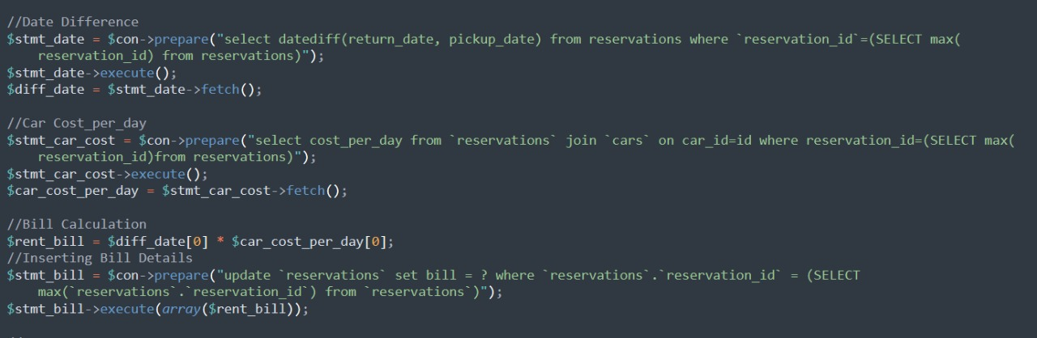**

**Code For Availaibility of the car for the Client to chose for the service**

**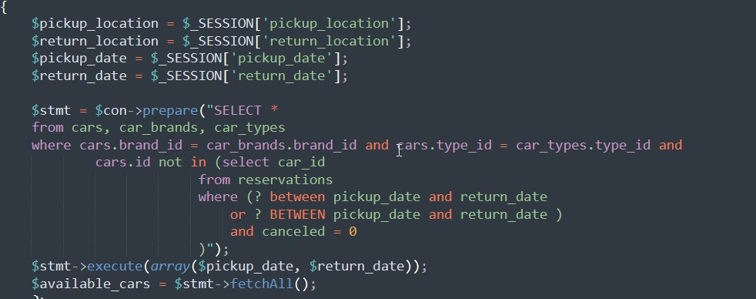**

**Code for displaying the Invoice once the reservation is done by Client**

**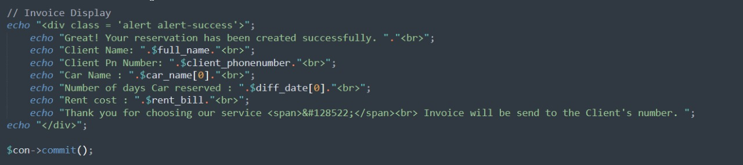**

# CHAPTER V: CONCLUSION & FUTURE ENHANCEMENT

Car rental business has emerged with a new goodies compared to the past experience where every activity concerning car rental business is limited to a physical location only. Even though the physical location has not been totally eradicated; the nature of functions and how these functions are achieved has been reshaped by the power of internet. Nowadays, customers can reserve cars online, rent car online, and have the car brought totheir door step once the customer is a registered member or go to the office to pick thecar.Our web based easyGo car rental system has offered an advantage to both customers as well as Car Rental Company to efficiently and effectively manage the business and satisfies customers need at the click of a button.

There is always a scope of improvement and Future Enhancement in a project. We are also looking towards the Future Enancement of the project by the following manner. First We have thought of knowing the location our Car which has been reserved by our client and also imply late fee if the user return the car after the return date. Second we have thought of a promocodes and discounts for the service to our clients on the basis of. Third to provide driver with the car service to the required clients. Fouth to have real secured Based payment in our project.

# 

# 

# 

# CHAPTER VI: SNAPSHOTS OF THE PROJECT

